

|  |  |  |  |  |  |  |  |  |
| --- | --- | --- | --- | --- | --- | --- | --- | --- |
|  | | | | | | | | |
|  | | LIBRARY APPLICATION | | | | |  | |
|  |  | | | | | | |  |
|  | | | |  |  | | | |
|  | | | | ION ANDREEA MARINA 223/2 |  | | | |
|  | | | | Course titleSoftware EngineeringTeacher’s name |  | | | |
|  | | |  | | |  | | |



|  |  |  |  |  |  |  |  |  |
| --- | --- | --- | --- | --- | --- | --- | --- | --- |
|  |  | | |  |  | | |  |
|  | Problem DescriptionLibrary | | | | | | |  |
|  |  | | |  |  | | |  |
|  |  | |  | | |  | |  |
|  |  |  | A library offers its subscribers a list of books that can be borrowed. For each subscriber we retain information about CNP (CPN),name, address, phone and unique code of user within the library. Each book can exist in one or more copies identified through unique codes. The library contains:   * Several terminals where subscribers can borrow books. In order to use a terminal, a subscriber must log in . After authentication, they see a list of books available at the time and the user can choose to borrow one or more copies. * One terminal: To return your rental the customer needs to go to a librarian which can connect to this terminal. All library terminal users see the updated list of available books. | | |  |  |  |
|  | | | | |
|  |  |  |  |
|  |  |

Use Cases

|  |  |  |  |
| --- | --- | --- | --- |
| ID and name | **UC-1: Sign Up** | | |
| Primary actor | New Customer | Secondary actors | Library System |
| Description | A new non-registered customer can go to a terminal and create an account by entering their credentials. If the information given by the user is correct, the user can choose to view its unique library ID or getting it send in an email. | | |
| Trigger | A New Customer goes to a terminal and wants to create one. | | |
| Preconditions | PRE-1. The Customer is not yet a subscriber. | | |
| Postconditions | POST-1. The customer has now become a subscriber and their credentials are now saved into the database. | | |
| Normal flow | 1. Creating an account. Signing up as a subscriber for the library.   1. The Customer clicks on the sign-up button to register.  2. The System loads the Sign-Up page.  3. The Customer enters their information as requested and a password which they must retype.  4. The System Validates the information. (see 1.0.E1, see 1.0.E2)  5. The System shows a pop-up where they ask the user how they want the unique ID to be communicated: show on the screen or through email.  5. The Customer chooses to see the unique ID on the screen and after noting it down they press “DONE”.(see 1.1)  6.The System returns to the original “Log IN” window. | | |
| Alternative flows | 1.1 Customer wants to get the unique code through email.  1. The customer requests that the unique ID to be sent through email.  2. The System shows a message that the Unique ID will be sent in at least 10 minutes to the customer’s email.  3.The Customer presses “OK”.  4.Return to step 6 of normal flow. | | |
| Exceptions | 1.0.E1 The Customer’s CPN (CNP) is already in the database.  4.a. System detects that CPN is already in the database and shows a message error.  4.b. System terminates Use Case.  1.0.E2 The Customer has entered non-valid data  4.a. The system shows an error message and asks the user to re-enter the data carefully.  4.b. Return to step 3. | | |

|  |  |  |  |
| --- | --- | --- | --- |
| ID and name | **UC-2: Log In** | | |
| Primary actor | Subscriber, Librarian, Admin | Secondary actors | Library System |
| Description | Someone wants to log-in into the system. | | |
| Trigger | A subscriber goes to a terminal/ A Libarian goes to it’s designated terminal/ The Admin decides to manage the library account. | | |
| Preconditions | PRE-1. The ACTOR already has an account! | | |
| Postconditions | POST-1. The system will show the designated view to the actor. | | |
| Normal flow | 1. The Person needs to log in 2. The Person goes to one of their designated terminals. 3. The Person clicks the Log-In button. 4. The System will show the Log-In Screen. 5. The Person enters their credentials. 6. The System validates the credentials of User. (View 2.0. E1) 7. The System loads the designated view to the user. | | |
| Alternative flows | No alternative Flows! | | |
| Exceptions | 2.0.E1 Person enters invalid credentials.  5.a. The system shows an error message saying that the entered credentials don’t coincide to the data in the system.  5.b. System returns to previous log-In Screen asking the user to reenter the correct information.  5.c. Return to step 4. | | |

|  |  |  |  |
| --- | --- | --- | --- |
| ID and name | **UC-3: Preview Books for Each Category** | | |
| Primary actor | Subscriber | Secondary actors | Library System |
| Description | After Logging in the page contains a preview for each category of the most borrowed books available. | | |
| Trigger | A Subscriber logs into the system. | | |
| Preconditions | PRE-1. The Subscriber has logged in. | | |
| Postconditions | POST-1. The Subscriber can now preview and select for view any book in top 3 of that Category. | | |
| Normal flow | 1. The System shows the most borrowed books. 2. After logging in , the subscriber can see 1-4 books in that category. 3. The Subscriber can view more about the category by clicking the View More button. (See UC-4). | | |
| Alternative flows | 3.1 No books available for one or more Categories.  1.a. The Subscriber can see the category but no preview will be available and instead of the books “No books available”.  1.b. Go back to step 2. | | |
| Exceptions | No exceptions | | |

|  |  |  |  |
| --- | --- | --- | --- |
| ID and name | **UC-4: View Books for Category.** | | |
| Primary actor | Subscriber | Secondary actors | Library System |
| Description | The Subscriber can choose to see all the books corresponding to the category selected. | | |
| Trigger | The Subscriber has clicked the View More Category or on the Category Name. | | |
| Preconditions | PRE-1. The Subscriber is logged in and clicks the button. | | |
| Postconditions | POST-1. The System shows all the books available for that category. | | |
| Normal flow | 1. Subscriber wants to see all of the available books for the category by clicking on the category. 2. The customer has logged in successfully. (SEE UC2) 3. The customer goes to a certain category and clicks on the category name. 4. The System shows all of the available books under that category. | | |
| Alternative flows | 4.1 Subscriber wants to see all available books under the category by clicking the View More Button.  2.1. The Subscriber clicks on the View More button (if it exists) that is found under the books previewed. | | |
| Exceptions | None | | |

|  |  |  |  |
| --- | --- | --- | --- |
| ID and name | **UC-5: View Filtered Books** | | |
| Primary actor | Subscriber | Secondary actors | Library System |
| Description | A subscriber wants to further filter the books shown for the books under the category they are seeing. | | |
| Trigger | A Subscriber chooses filters from the filter panel while viewing books under a category. | | |
| Preconditions | PRE-1. The Subscriber is logged in and is viewing books only under a category. | | |
| Postconditions | POST-1. The System shows books under the category filtered. | | |
| Normal flow | 1. The Subscriber wants to see the books filtered. 2. The Subscriber wants to filter the books under the category. 3. The Subscriber clicks on the filter drop-menu. 4. The System shows now the Panel with the filtering items. 5. The Subscriber selects the filters from the panel. (See 5.0.E1.) 6. The System shows the books under the filter. (See 5.1) | | |
| Alternative flows | 5.1 The Subscriber wants to see the books filtered but there are none.  5.a. The System shows the text “No Available books under Filter” | | |
| Exceptions | 5.0.E1 The Subscriber enters non-valid filters.  5,a. The Subscriber enters invalid strings in text-fields.  5.b. The System shows and error message and clears the text field. | | |

|  |  |  |  |
| --- | --- | --- | --- |
| ID and name | **UC-6: Search books** | | |
| Primary actor | Subscriber. | Secondary actors | Library System |
| Description | The subscriber wants to search for certain books . They can do so by entering into the search bar something related to the book’s. | | |
| Trigger | The subscriber enters into the search bar what they are searching for and clicks enter or the button “Search”. | | |
| Preconditions | PRE-1. The Customer is logged in into the terminal. | | |
| Postconditions | POST-1. The System needs to show all of the books corresponding to that search string. | | |
| Normal flow | 1. Searching Book/s by Using the Search Bar.   1. The Subscriber is on the main page and wants to search books by a certain attribute. (eg. Name, Author)  2. The System loads the books that contain the string. (see 6.1) | | |
| Alternative flows | 6.1 No book available containing string.  2.1. The System shows instead of the books the text “No books containing criteria is available”. | | |
| Exceptions | No exceptions. | | |

|  |  |  |  |
| --- | --- | --- | --- |
| ID and name | **UC-7: View Book Details** | | |
| Primary actor | Subscriber | Secondary actors | Library System |
| Description | A Subscriber wants to see details about a certain book or even borrow it. They will click on the book and their multiple actions are available. | | |
| Trigger | The Subscriber clicks on one of the books shown on the page. | | |
| Preconditions | PRE-1. The Subscriber is logged in and a book is shown on the screen. | | |
| Postconditions | POST-1. The System shows a new page with the information of the book and possibility of adding it to the borrowing basket. | | |
| Normal flow | 1. Viewing a Book’s Details. 2. The Subscriber wants to see the details about a certain book. 3. The Subscriber clicks on the book cover or name of book. 4. The System shows the subscriber a new page where the details are and the possibility of adding it to the basket is. | | |
| Alternative flows | None. | | |
| Exceptions | None. | | |

|  |  |  |  |
| --- | --- | --- | --- |
| ID and name | **UC-8: Add Book to Basket** | | |
| Primary actor | Subscriber. | Secondary actors | Library System |
| Description | The subscriber wants to add a certain book or multiple copies of that book in the basket. | | |
| Trigger | When the Subscriber is viewing the book they have the button add to basket which has next to it the quantity which is by default set to ‘0’. | | |
| Preconditions | PRE-1. The Customer is logged in into the terminal. The Customer is viewing a book’s details. | | |
| Postconditions | POST-1. The System will update the Customer’s Basket and add the item with its quantity in the basket. | | |
| Normal flow | 1. Adding Book to the Basket 2. The Subscriber clicks on a book they want to view. 3. While Viewing the button “Add to Basket” will be available. The Subscriber can choose the quantity and then add it to the basket. 4. The System adds the item/s to the basket. (See 8.0 E1,8.0 E2) 5. The Basket will now have the items counter increased. | | |
| Alternative flows | None. | | |
| Exceptions | 8.0.E1 The Subscriber has chosen too many units  3.1. The System does not find enough units for the subscriber’s desired book.  3.2. The System shows a message asking the subscriber if they still want the number available right now of units for that book.  3.3.  3.3.a.1. The Subscriber chooses “YES.  3.3.a.2. The System puts the number of available units in the basket.  3.3.b.1 The Subscriber chooses “NO”.  3.3.b.2. The quantity is reset and the system goes back to the viewing page of the item.  8.0.E2 The Book has become unavailable.  3.1. The System finds that the book has become unavailable at the moment.  3.2. The System shows an error message to the Subscriber.  3.3. The System returns to the window before the viewing of the book. | | |

|  |  |  |  |
| --- | --- | --- | --- |
| ID and name | **UC-9: View Borrowing Basket** | | |
| Primary actor | Subscriber. | Secondary actors | Library System |
| Description | The subscriber wants to see the basket of books they have added to borrow from the library. | | |
| Trigger | At any time besides viewing the book , while logged in, the subscriber can click on the right upper corner basket to see them. | | |
| Preconditions | PRE-1. The Customer is logged in into the terminal. The Customer is not viewing a book’s details. | | |
| Postconditions | POST-1. The System loads the page where the basket can be viewed, edited and the borrowing choosing can be finished, | | |
| Normal flow | 1. Viewing Borrowing Basket 2. The Subscriber clicks the basket. 3. The System loads the page, where a list of all items the subscriber wants to borrow are. | | |
| Alternative flows | 9.1. There are no books in the Basket.  2.1. The System loads the page not showing any items but the text “No items have been yet added” and shows a button which redirects the user to the front page. | | |
| Exceptions | None. | | |

|  |  |  |  |
| --- | --- | --- | --- |
| ID and name | **UC-10: Modify Basket** | | |
| Primary actor | Subscriber. | Secondary actors | Library System |
| Description | The subscriber can modify the basket while viewing it before check-out. They can remove items or edit the quantity of them. | | |
| Trigger | The subscriber clicks the button “Modify” while viewing their baskets. | | |
| Preconditions | PRE-1. The Customer is logged in into the terminal. The Subscriber has added items in the cart already. The Subscriber is viewing the cart. | | |
| Postconditions | POST-1. The System will update the Subscriber’s basket. | | |
| Normal flow | 1. The Subscriber edits the basket. 2. The Subscriber is viewing the basket. They click on the modify button. 3. The System will add methods to remove and modify the quantity for each item in the basket. 4. The Subscriber changes or does not change the quantity’s or remove items from the basket. 5. The System validates the new change . (See 10.0.E1.) 6. The System now shows the basket modified. | | |
| Alternative flows | None. | | |
| Exceptions | 10.0.E1 The Subscriber has chosen too many units  4.1. The System does not find enough units for the subscriber’s desired book.  4.2. The System shows a message asking the subscriber if they still want the number available right now of units for that book.  4.3.  4.3.a.1. The Subscriber chooses “YES.  4.3.a.2. The System puts the number of available units in the basket.  4.3.b.1 The Subscriber chooses “NO”.  4.3.b.2. The System deletes the item from the basket.  4.4. The System shows the new basket updated.  10.0.E2 The Book has become unavailable.  4.1. The System finds that the book has become unavailable at the moment.  4.2. The System shows an error message to the Subscriber.  4.3. The System deletes the item from the basket and shows it updated. | | |

|  |  |  |  |
| --- | --- | --- | --- |
| ID and name | **UC-11: Finishing Choosing Items.** | | |
| Primary actor | Subscriber. | Secondary actors | Library System |
| Description | After choosing the books they want the subscriber will want to finish choosing the items . They can do so by choosing to finish the borrowing. | | |
| Trigger | When the Subscriber is viewing the list of items they want to borrow they can click the button finish order. | | |
| Preconditions | PRE-1. The Customer is logged in into the terminal. The Subscriber has items in their cart and they are viewing it. | | |
| Postconditions | POST-1. The number for each time must be available at the time of purchasing the products. If they are the system will mark them as unavailable and proceed to save the order. | | |
| Normal flow | 1. Finishing Order. 2. The Subscriber is viewing the list. 3. The Subscriber clicks on “Finish”. 4. The System validates once again if the items are in stock. 5. The System shows a success message and adds the order to the subscriber’s account. | | |
| Alternative flows | None. | | |
| Exceptions | 11.0.E1 Some books have become unavailable.  3.1. The System finds that some books have been borrowed by other people in the meantime.  3.3. The System shows an error message informing the Subscriber of the books that are currently unavailable or how many units they have.  3.4. The System returns the subscriber to the viewing page of the books they wanted to borrow. | | |

|  |  |  |  |
| --- | --- | --- | --- |
| ID and name | **UC-12: Search For Subscriber.** | | |
| Primary actor | Librarian. | Secondary actors | Library System |
| Description | The librarian wants to search for a certain subscriber by their id or CPN. They want more information about it or they need it so that the books they brought back to be marked as returned. | | |
| Trigger | After the librarian has logged in the terminal, the only option they have is to enter the ID/CPN of the subscriber. After clicking search or pressing enter the action will be done. | | |
| Preconditions | PRE-1. The Librarian must be logged in. | | |
| Postconditions | POST-1. The Subscriber is registered in the system.  POST-2. The items are marked as available. | | |
| Normal flow | 1. Searching for a Subscriber. 2. The Librarian enters the ID/CPN of Subscriber in the terminal. 3. The System validates the credentials. (View 12.0.E1) 4. The System now shows full details of Subscriber. | | |
| Alternative flows | None. | | |
| Exceptions | 12.0.E1 The Subscriber’s credentials are wrong  2.1. The System does not find the customer’s credentials.  2.2. The System shows an error message to the librarian.  2.3. Return to Step 1 of 12.0. | | |

|  |  |  |  |
| --- | --- | --- | --- |
| ID and name | **UC-13: Show Subscriber’s Rental.** | | |
| Primary actor | Librarian. | Secondary actors | Library System |
| Description | The librarian wants to see the rentals of the subscriber. After entering the subscriber’s credentials they will be able to choose between seeing their rentals or information about it. The librarian chooses to see their rentals. | | |
| Trigger | After entering correct credentials of subscriber the Librarian chooses the “Show Rentals” button. | | |
| Preconditions | PRE-1. The Librarian must be logged in.  PRE-2. The Librarian must have entered valid credentials of a subscriber’s. | | |
| Postconditions | POST-1. The System shows a list of the subscriber’s rentals. | | |
| Normal flow | 1. Viewing Subscriber’s rental. 2. The Librarian is viewing the subscriber’s information. 3. The Librarian clicks on “Show Rentals”. 4. The System shows the rentals of the subscriber by date and firstly the ones they are currently borrowing. | | |
| Alternative flows | None. | | |
| Exceptions | None | | |

|  |  |  |  |
| --- | --- | --- | --- |
| ID and name | **UC-14: Show Information about Subscriber.** | | |
| Primary actor | Librarian. | Secondary actors | Library System |
| Description | The librarian wants to search for a certain subscriber by their id or CPN. They want more information about it or they need it so that the books they brought back to be marked as returned. | | |
| Trigger | After the librarian has logged in the terminal, the only option they have is to enter the ID/CPN of the subscriber. After clicking search or pressing enter the action will be done. | | |
| Preconditions | PRE-1. The Librarian must be logged in. | | |
| Postconditions | POST-1. The Subscriber is registered in the system.  POST-2. The items are marked as available. | | |
| Normal flow | 1. Searching for a Subscriber. 2. The Librarian enters the ID/CPN of Subscriber in the terminal. 3. The System validates the credentials. (View 12.0.E1) 4. The System now shows full details of Subscriber. | | |
| Alternative flows | None. | | |
| Exceptions | 14.0.E1 The Subscriber’s credentials are wrong  2.1. The System does not find the customer’s credentials.  2.2. The System shows an error message to the librarian.  2.3. Return to Step 1 of 12.0. | | |

|  |  |  |  |
| --- | --- | --- | --- |
| ID and name | **UC-15: Return Books Corresponding to Rental** | | |
| Primary actor | Librarian | Secondary actors | Library System |
| Description | After entering the subscriber’s credentials the librarian wants to mark the books given as either lost or returned , now being back in stock. If the customer has lost the book they will be fined with a 100-200 ron fine, decided at the place by the Librarian. | | |
| Trigger | A Subscriber comes with books to return and the librarian needs to reintroduce them in the system. | | |
| Preconditions | PRE-1. The Subscriber has books they are currently renting and the librarian has entered the subscriber’s credentials in the terminal ( either the username, the email, or unique code). | | |
| Postconditions | POST-1. All of the book units increase and if the book was no longer available now it will be and will appear for the subscriber’s search. | | |
| Normal flow | 1. Retrieving All Books.   1. The Librarian chooses one of the Rentals the subscriber is currently wanting to retrieve.  2. The System loads the list of books the Subscriber has rented in that rental.  3.a. If every book is being returned, the librarian does not have to mark anything as lost and can mark them all as returned.  4. The System sets the book unit states as now available for rental.  5. The System sets the Rental as concluded, | | |
| Alternative flows | 15.1 Customer has lost one or more books.  3.a. The customer has lost some books so the librarian marks the units as lost and fines the customer a fine. | | |
| Exceptions | - | | |

|  |  |  |  |
| --- | --- | --- | --- |
| ID and name | **UC-16: Manage Subscribers** | | |
| Primary actor | Admin | Secondary actors | Library System |
| Description | An admin can manage the subscribers by default after logging in. They can see all current subscribers and delete them after selecting one of them. | | |
| Trigger | The admin logs into their account. | | |
| Preconditions | PRE-1. The admin has logged in. | | |
| Postconditions | POST-1. The subscribers are shown to the admin. | | |
| Normal flow | 1. The Subscribers are shown.   1. The System loads the list with all of the subscribers.  2. The Admin can choose to see details about the subscriber.  3. The System shows more details about the subscriber. | | |
| Alternative flows | - | | |
| Exceptions | - | | |

|  |  |  |  |
| --- | --- | --- | --- |
| ID and name | **UC-17: Delete Subscriber** | | |
| Primary actor | Admin | Secondary actors | Library System |
| Description | The admin can choose to delete a subscriber. | | |
| Trigger | The admin chooses a subscriber and chooses to delete. | | |
| Preconditions | PRE-1. The Subscriber was selected. | | |
| Postconditions | POST-1. All of the information about the subscriber is erased and cannot be retrieved. | | |
| Normal flow | 1. The admin chooses to delete a subscriber.   1. The admin selects a subscriber .  2. The System loads more information about the subscriber and gives the admin the option to delete the subscriber.  3. The Admin chooses to delete the subscriber.  4. The System erases all of the information about the subscriber, | | |
| Alternative flows | - | | |
| Exceptions | - | | |

|  |  |  |  |
| --- | --- | --- | --- |
| ID and name | **UC-18: Add Librarian** | | |
| Primary actor | Admin | Secondary actors | Library System |
| Description | The library employees a new person. Due to that, the librarian needs to register the information for the librarian and retain their information. | | |
| Trigger | A New Librarian is employed and they need to be stored in the system. | | |
| Preconditions | PRE-1. The librarian cannot be found in the system. | | |
| Postconditions | POST-1. The customer has now become a subscriber and their credentials are now saved into the database. | | |
| Normal flow | 1. Admin logs the new employee data.   1. The Admin chooses to manage the librarians.  2. The System loads the librarians employed at the library.  3. The Admin enters the data corresponding to the new librarian.  4. The System validates the information ( see 18.0.E1, see 18.0.E2)  5.The System shows the admin the auto-generated unique code corresponding to the employee.  6. The System updates the list of librarians including the newly added one. | | |
| Alternative flows | - | | |
| Exceptions | 18.0.E1 The introduced employee data already exists in the system.  4.a. The System identified at least one of the unique identificators ( CPN, USERNAME,EMAIL) already logged into the system.  4.b. The System shows where the mistake might be.  4.c. Return to step 3. | | |
| Exceptions | 18.0.E2 The introduced employee data is not valid.  4.a. The System could not validate the introduced data.  4.b. The System shows where the mistake might be.  4.c. Return to step 3. | | |

|  |  |  |  |
| --- | --- | --- | --- |
| ID and name | **UC-19: Modify Librarian** | | |
| Primary actor | Admin | Secondary actors | Library System |
| Description | One of the employees have had some of their information changed , so the information needs to be update. This can be easily done by the admin. | | |
| Trigger | A Librarian has changed their information. | | |
| Preconditions | PRE-1. The admin is logged in and the librarian’s information is saved. | | |
| Postconditions | POST-1. The librarian’s information has now been updated. | | |
| Normal flow | 1. Update librarian information.   1. The admin chooses to manage the librarians.  2. The System loads all of the librarians that are employed at this library.  3. The Admin chooses the librarian they want to update.  4. The System loads the information about the librarian.  5. The Admin changes the data they want to choose.  6. The System updates the information for the librarian and saves it. (see 19.0.E1) | | |
| Alternative flows | - | | |
| Exceptions | 19.0.E1 The Admin is trying to update the librarian with non-valid data.  1. The System fails to validate the new data given and highlights where the mistake was.  2. The System lets the admin modify the data again. 3. Going back to step 5. | | |

|  |  |  |  |
| --- | --- | --- | --- |
| ID and name | **UC-20: Delete Librarian** | | |
| Primary actor | Admin | Secondary actors | Library System |
| Description | A librarian is either unemployed by the library or leaves their job so their data gets removed. | | |
| Trigger | A librarian leaves their job. | | |
| Preconditions | PRE-1. The Librarian’s information is saved and the admin is logged in. | | |
| Postconditions | POST-1. The Librarian’s information is removed. | | |
| Normal flow | 1. Admin removes the librarian. 2. The admin chooses to manage the librarians. 3. The system loads the librarians of the library information. 4. The admin chooses one of the librarians shown. 5. The system shows the information about the selected librarian. 6. The admin chooses to delete the librarian. 7. The System removes the librarian and updates the librarians. | | |
| Alternative flows | - | | |
| Exceptions | - | | |

|  |  |  |  |
| --- | --- | --- | --- |
| ID and name | **UC-21: Update Book** | | |
| Primary actor | Admin | Secondary actors | Library System |
| Description | A book needs their information updated, being it the number of units or basic information about it. The admin can manage that information. | | |
| Trigger | A book needs updating. | | |
| Preconditions | PRE-1. The book’s information is stored. The admin is logged in. | | |
| Postconditions | POST-1. The book’s data is now updated and the system shows the book updated. | | |
| Normal flow | 1. Update book information.   1. The admin chooses to manage the books.  2. The System loads all of the books information found in the library.  3. The Admin chooses the book they want to update the information,  4. The System loads the information about the book and the units it has and their state.  5. The Admin changes book details without changing the number of units. (see 21.1,21.2).  6.The System updates the book details. (see 21.0.E1). | | |
| Alternative flows | 21.1. The book increases the number of units for the book.  5.a. The Admin increases the number of units.  5.b. The System generates the unique codes for the new books in stock and marks them available to rent.  6. The System updates the book details.  21.2. The book decreases the number of units for the book.  5.a. The Admin decreases the number of units.  5.b. The System removes as much books lost as it can. If the number of units decreased is higher than that it starts removing available for rent books.  6. The System updates the book details. | | |
| Exceptions | 21.0.E1 The Admin introduces incorrect new book details.  6.a. System fails to validate the data .  6.b. The System highlights the parts were the admin introduced wrong data.  6.c. Going back to step 5. | | |

|  |  |  |  |
| --- | --- | --- | --- |
| ID and name | **UC-22: Add Book** | | |
| Primary actor | Admin | Secondary actors | Library System |
| Description | A new book is now available at the library. It needs to be added in the system. The admin must enter all of its details and number of units. | | |
| Trigger | A new book is now available for renting. | | |
| Preconditions | PRE-1. The Book’s details are not found. The admin is logged in. | | |
| Postconditions | POST-1. The System will make the new book available for renting. | | |
| Normal flow | 1. Adding the new book.   1. The Admin chooses to manage the books.  2. The System loads the books found in the library.  3. The Admin enters the data corresponding to the new book.  4. The System validates the information ( see 18.0.E1, see 18.0.E2)  5.The System shows the admin the units of it with their auto-generated code, all available for renting.  6. The System updates the list of books including the newly added one. | | |
| Alternative flows | 22.0.E1. The book can already be found in the system.  1. The customer requests that the unique ID to be sent through email.  2. The System shows a message that the Unique ID will be sent in at least 10 minutes to the customer’s email.  3.The Customer presses “OK”.  4.Return to step 6 of normal flow. | | |
| Exceptions | 22.0.E1. The book can already be found in the system.  1. The System identifies the book’s ISBC in the system.  2. Return to step 3.  22.0.E2. The book can already be found in the system.  1. The System fails to validate the information given about the new book.  2. The System highlights the problems for the admin.  3. Return to step 3. | | |

|  |  |  |  |
| --- | --- | --- | --- |
| ID and name | **UC-23: Remove Book** | | |
| Primary actor | Admin | Secondary actors | Library System |
| Description | A book will no longer be available in this library so their information will be deleted. | | |
| Trigger | A book is no longer available. | | |
| Preconditions | PRE-1. The book exists in the system. The admin is logged in. | | |
| Postconditions | POST-1. The book and it’s units are now no longer available. | | |
| Normal flow | 1. Deleting a book. 2. The admin chooses to manage the books. 3. The system loads the books of the library information. 4. The admin chooses one of the books shown. 5. The system shows the information about the selected book and their information. 6. The admin chooses to delete the book and it’s units. 7. The System removes the books and removes the books and its units. | | |
| Alternative flows | - | | |
| Exceptions | - | | |

|  |  |  |  |
| --- | --- | --- | --- |
| ID and name | **UC-24: Log Out** | | |
| Primary actor | Admin, Subscriber, Librarian | Secondary actors | Library System |
| Description | The person that is logged in wants to log out. | | |
| Trigger | A person wants to log out. | | |
| Preconditions | PRE-1. The actor is logged in into the application. | | |
| Postconditions | POST-1. The actor is now logged out of the application. | | |
| Normal flow | 1. Logging out. 2. The actor wants to log out so they choose that option on the page. 3. The System logs the actor out. | | |
| Alternative flows | - | | |
| Exceptions | - | | |

Use Case Planification:

First Iteration: Use Case 1-11 (Sign up , log in and subscriber)  
 Second Iteration: Use Case 12- 17 (librarian)

Third Iteration: Use Case 18-24(admin)

**UML CLASS DIAGRAM**

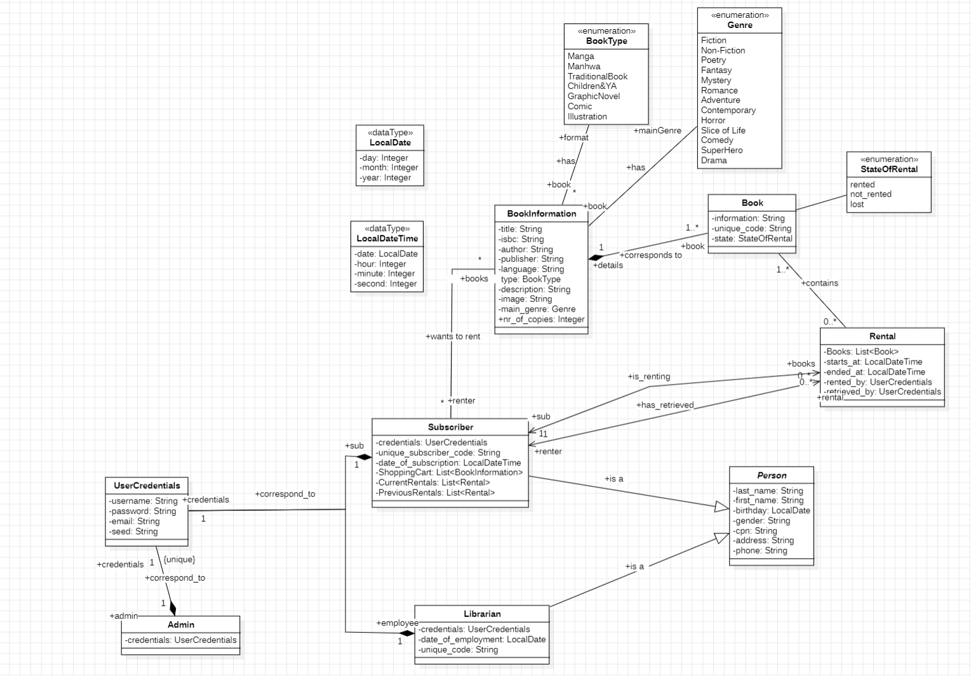

**PROTOTYPE OF INTERFACE  
 (prone to change)**

LOG IN

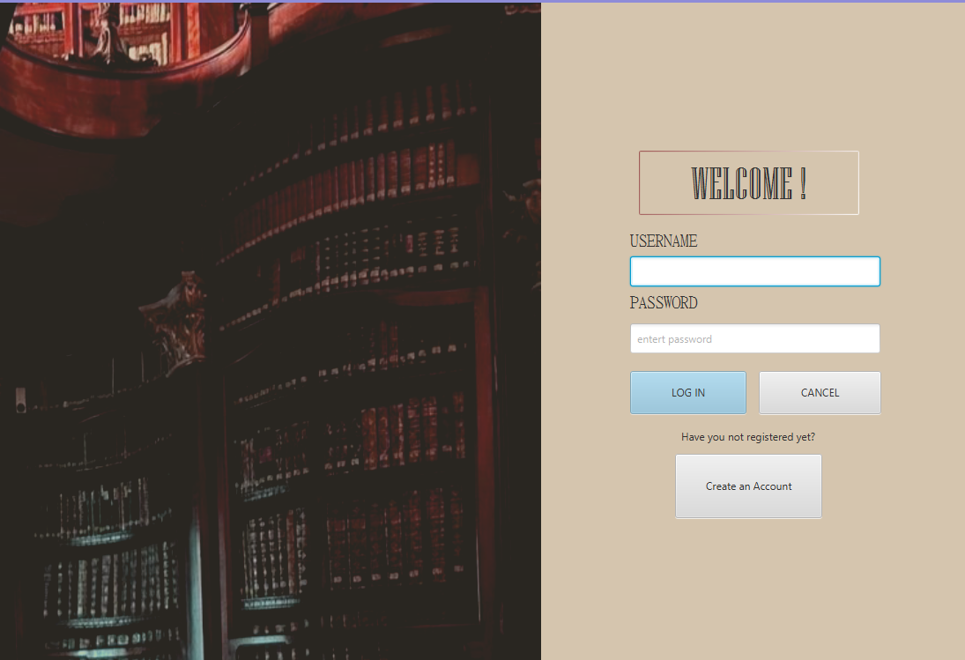

SIGN UP ( only new customers will be able to)

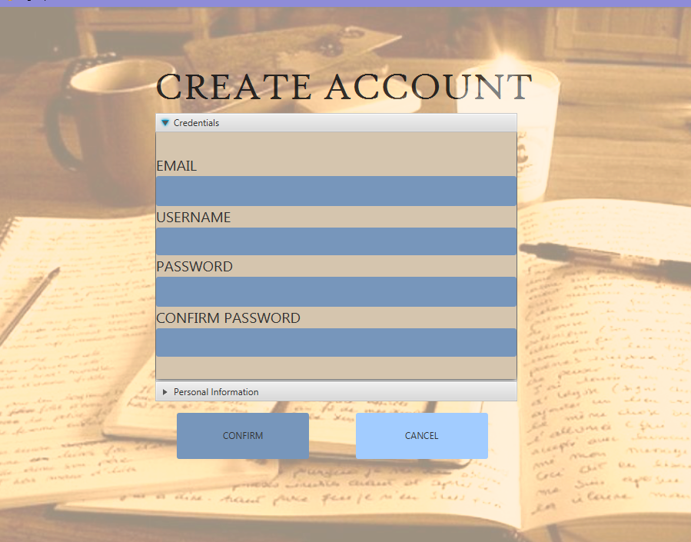

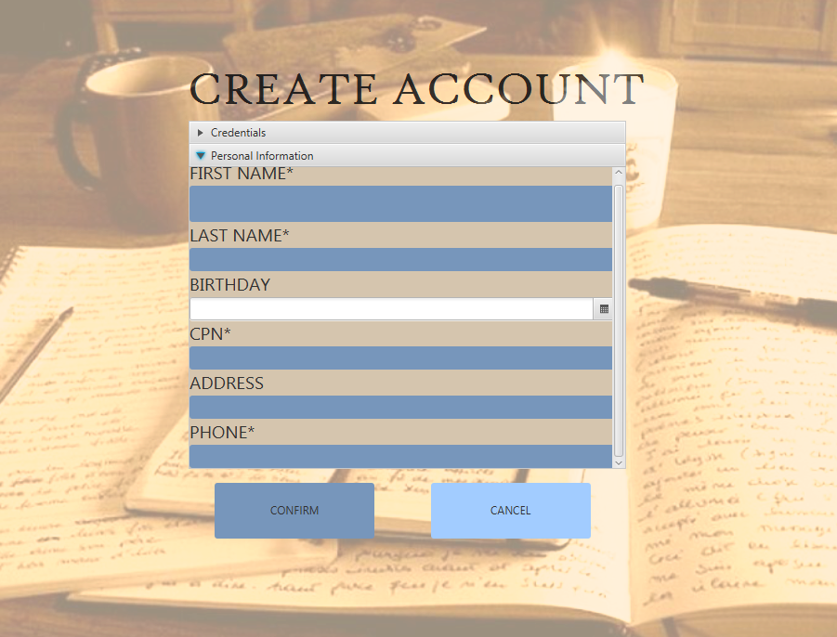

SUBSCRIBER VIEWS

--MAIN PAGE--

 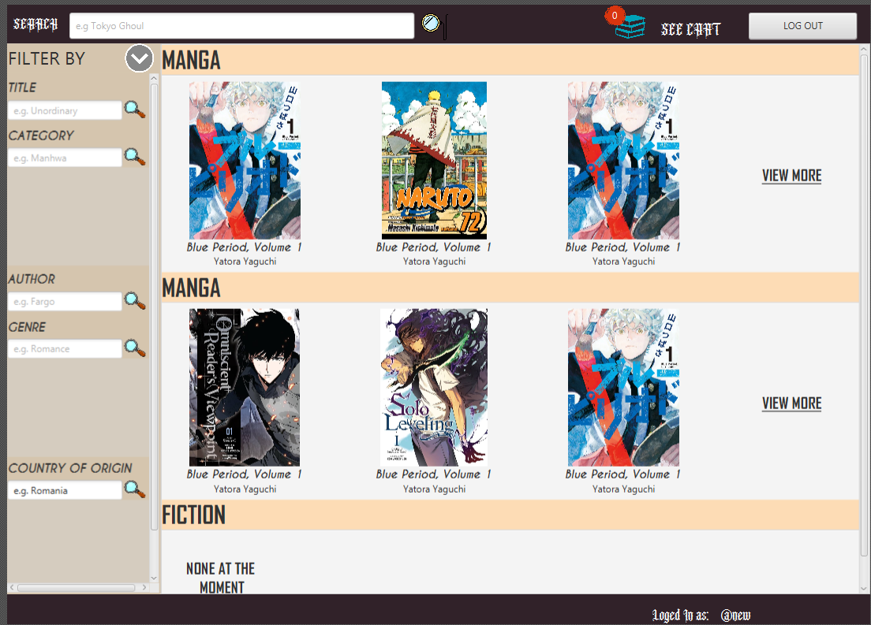

 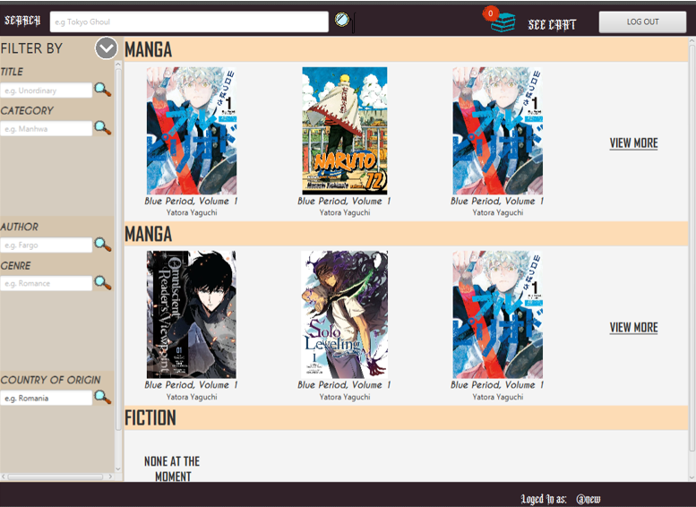

-- PREVIEW OF BOOK –

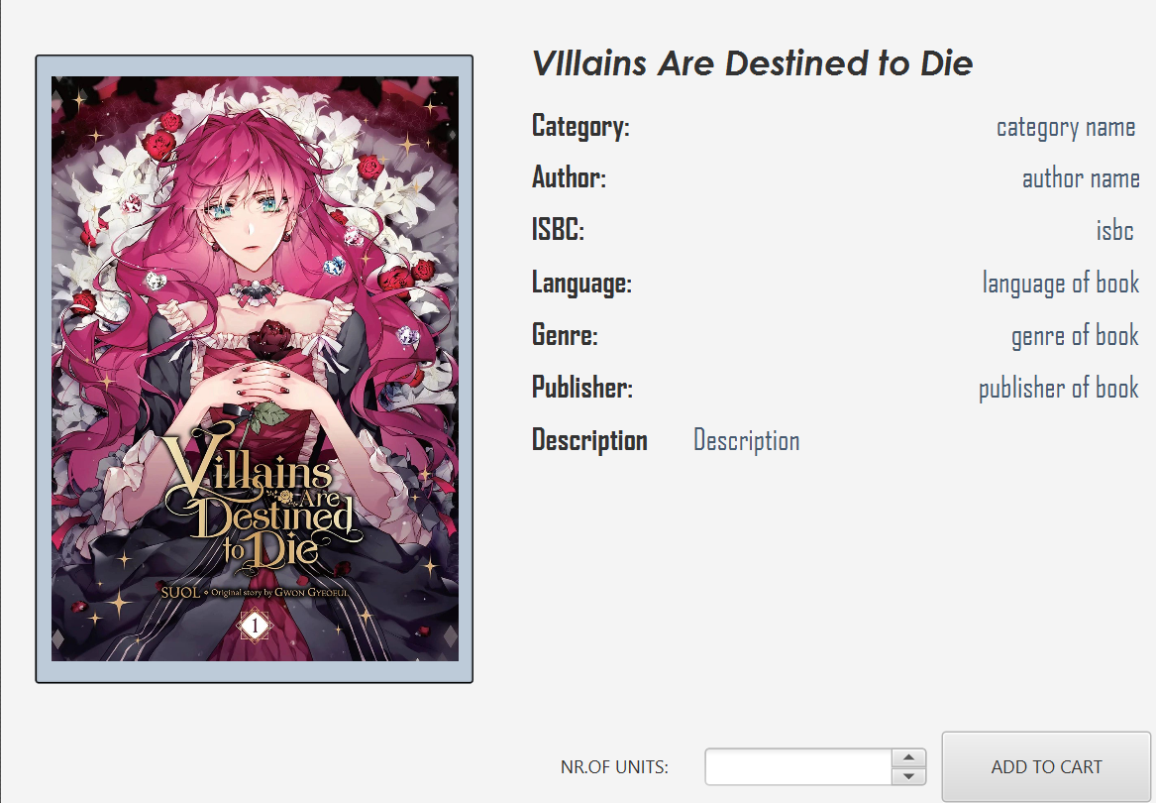

--SHOPPING CART—

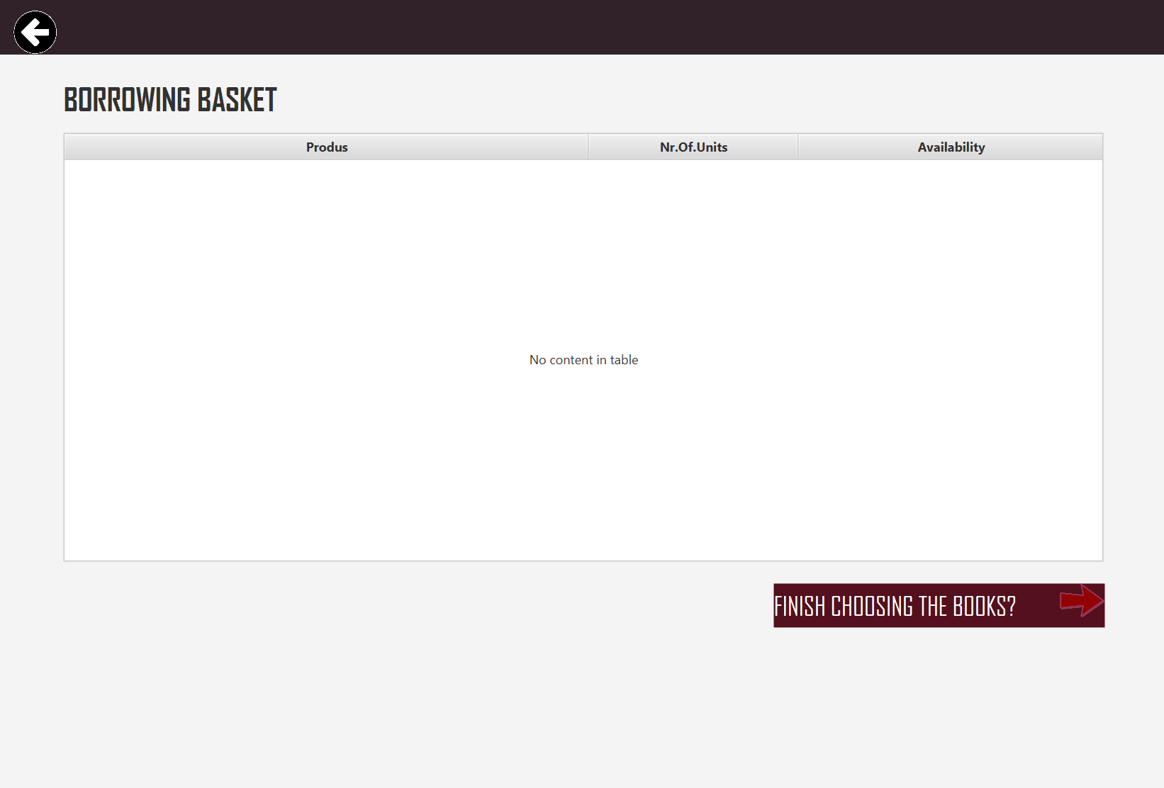

-- LIBRARIAN VIEWS—

--MAIN LIBRARIAN VIEW--

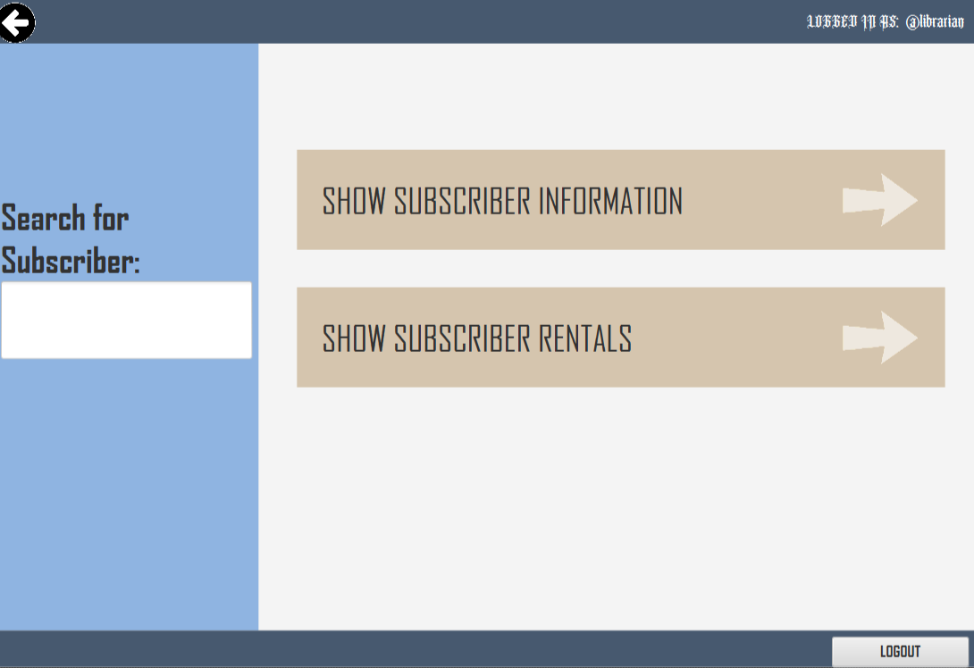

-- SUBSCRIBER INFORMATION –

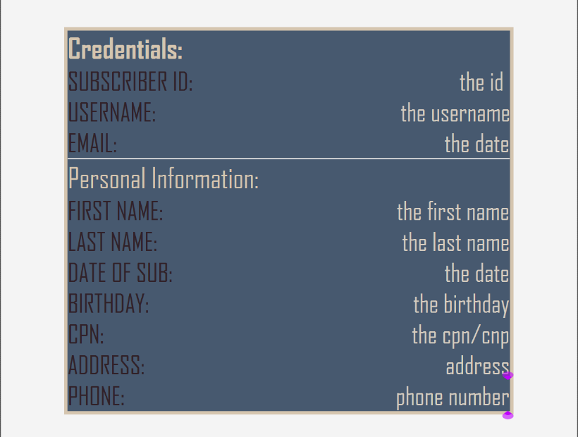

--SUBSCRIBER RENTALS INFORMATION—

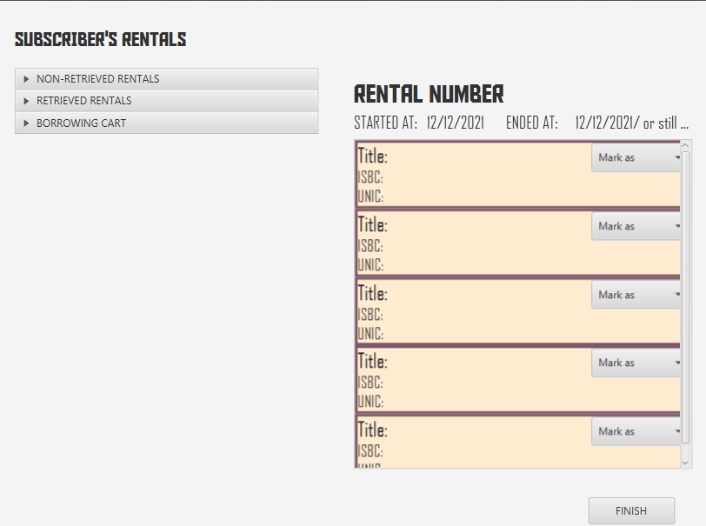

For each rental the librarian can see the details of each book. If they are looking at a rent that is currently active, they can mark it as lost or retrieved.   
If they are looking at retrieved rentals the markers are already set.  
For borrowing basket they can only preview it!

--ADMIN VIEWS—

--After logging in they can directly manage subscribers--

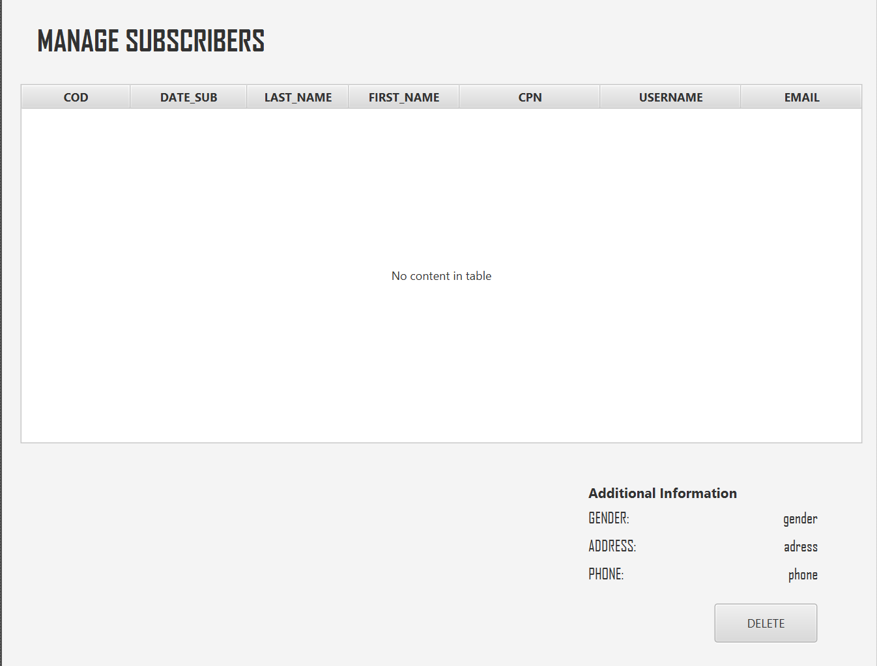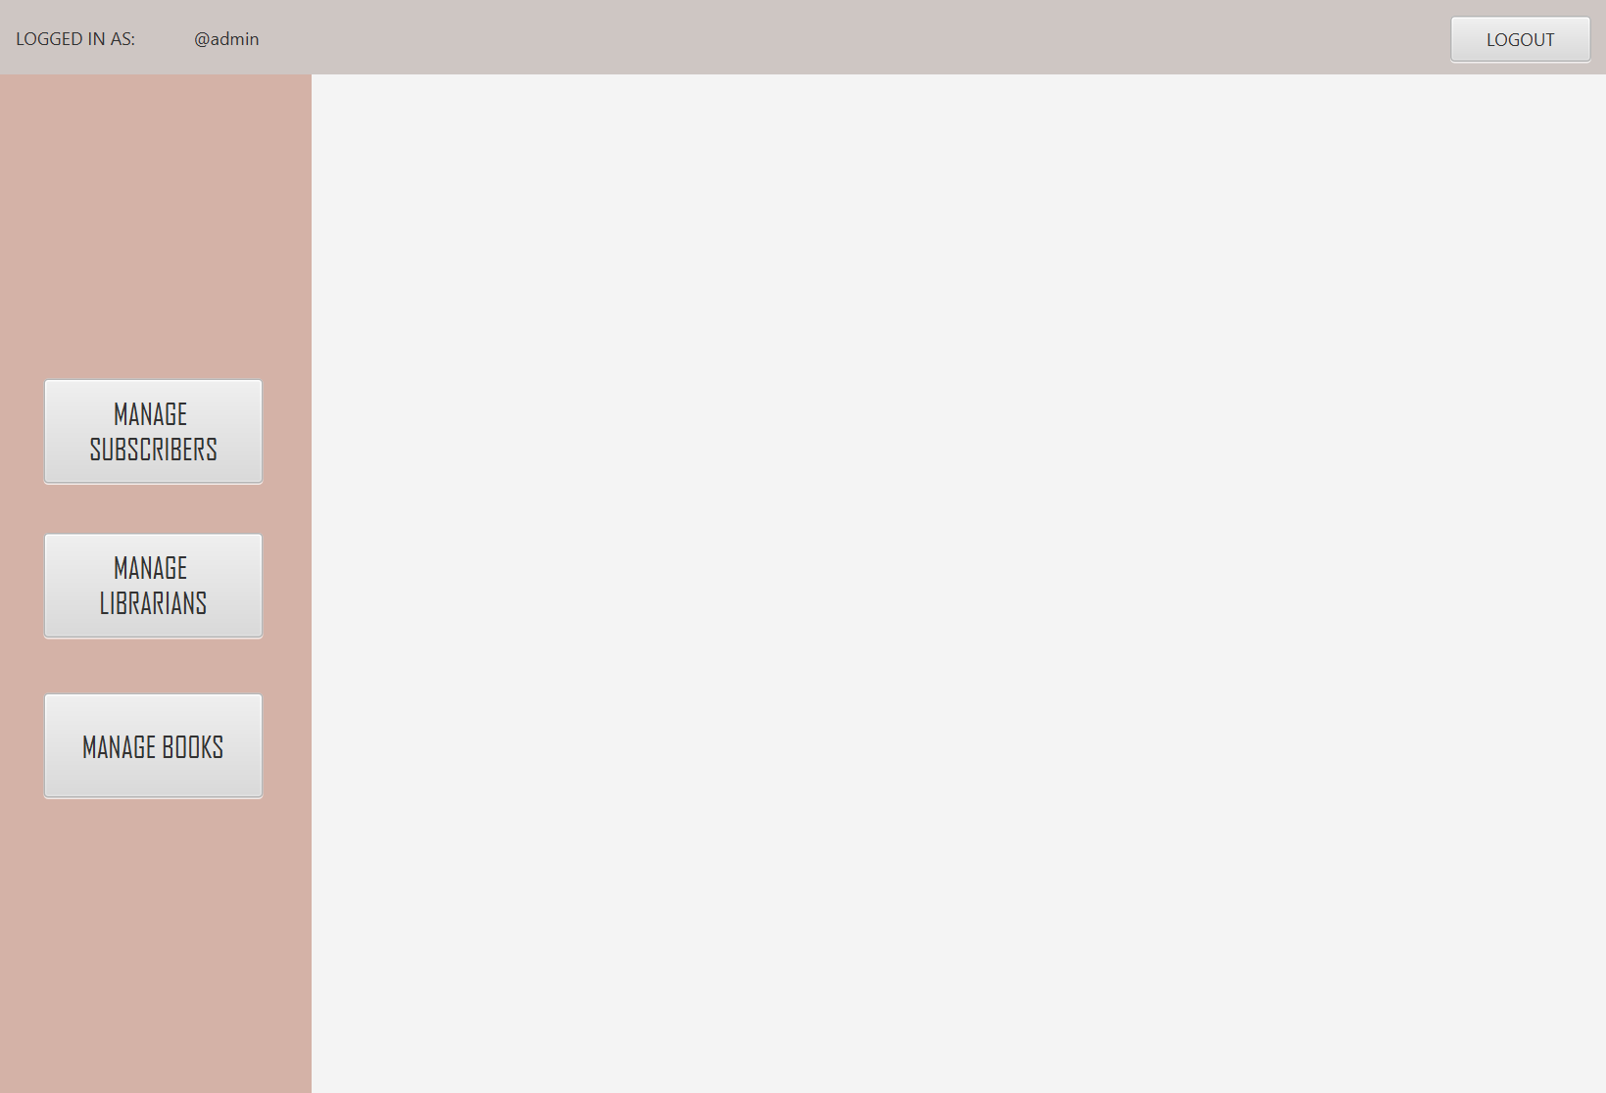

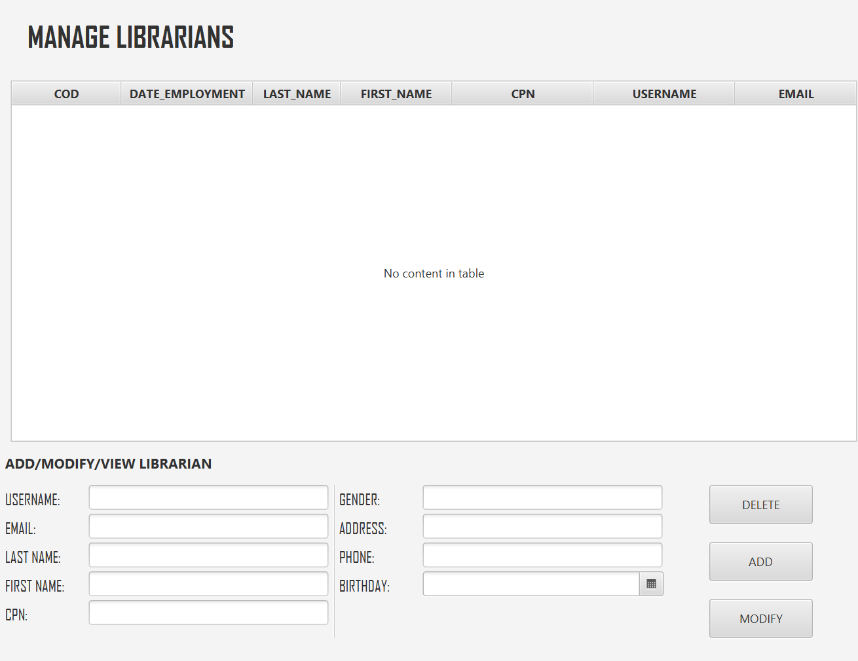-- MANAGE LIBRARIANS--  


-- MANAGE BOOKS—

(it is also incorporated as a subscene but I am putting it alone for the sake of detailing it)  
  
